**SE470**

**Example Software Requirements Specification**

**Document**

**Version: (0)** **Date: (11/29/2016)**

**Table of Contents**

1. Introduction 3

1.1 Purpose 3

1.2 Scope 3

1.3 Definitions, Acronyms, and Abbreviations. 3

1.4 References 4

1.5 Overview 4

2. The Overall Description 5

2.1 Product Perspective 5

2.1.1 System Interfaces 5

2.1.2 Interfaces 6

2.1.3 Hardware Interfaces 6

2.1.4 Software Interfaces 6

2.1.5 Communications Interfaces 6

2.1.6 Memory Constraints 7

2.1.7 Operations 7

2.1.8 Site Adaptation Requirements 7

2.2 Product Functions 7

2.3 User Characteristics 9

2.4 Constraints 10

2.5 Assumptions and Dependencies 10

2.6 Apportioning of Requirements. 10

3. Specific Requirements 10

3.1 External Interfaces 10

3.2 Functions 11

3.3 Performance Requirements 12

3.4 Logical Database Requirements 12

3.5 Design Constraints 13

3.5.1 Standards Compliance 13

3.6 Software System Attributes 13

3.6.1 Reliability 13

3.6.2 Availability 13

3.6.3 Security 13

3.6.4 Maintainability 13

3.6.5 Portability 13

4. Change Management Process 14

5. Document Approvals 14

6. Supporting Information 14

Setup 15

Play 15

Salvo Variant (not implemented here) 15

# 1. Introduction

## 1.1 Purpose

The Purpose of this **(Draft)** Software Requirements Specification (SRS) is to describe the requirements for a computer-based version of the board game of “Battlehsip” (Milton Bradely 1967) for the SE470 (Nov 2016) class project. “Battlehship” is a strategy guessing game where each player attempts to guess the location of an opponent's ships within a fixed and bounded grid and by doing so 'sinks' them. The first to find all of the opponent’s ships is declared the winner.

The intended audience is the members of the development team and the instructor. It shall be used as a design source and a means for creating acceptance testing criteria for the release of the project.

It should be noted that this document is intended to change as needed to update descriptions and requirements as more information is discovered or conditions change during development.

## 1.2 Scope

The scope of this document and subsequent development is to describe the requirements for a stand-alone computer desktop version of the classic board game of “Battleship”. (See Appendix A for a complete set of rules). The application will run on a standard desktop computer with a Windows Operating System, (Windows 7 or greater). The game will consist of a desktop/laptop user interface resembling the physical board game produced by Milton/Bradely (1967) (Details below). It will be controlled by a standard computer keyboard and mouse and will be displayed on a standard computer monitor. It will not support other input devices or run on other operating systems or hardware. It is not intended for internet or networked computer use and will need to be installed on all computers that wish to use it.

The targeted user is a standard physically-able computer user which normal vision and physical abilities to use a keyboard and mouse. The user is expected to have an interest in simple but fun strategy guessing games such as “Battleship”, “Concentration” or “Go Fish”.

The goal of this project is to produce a simple replica of the classic board game for use on a standard desktop computer.

## 1.3 Definitions, Acronyms, and Abbreviations.

**Artificial intelligence** (**AI**) is intelligence exhibited by machines. In computer science, an ideal "intelligent" machine is a flexible rational agent that perceives its environment and takes actions that maximize its chance of success at some goal. Colloquially, the term "artificial intelligence" is applied when a machine mimics "cognitive" functions that humans associate with other human minds, such as "learning" and "problem solving".

**Allied Grid:** 10 x 10 Grid of squares displayed in the user interface where a player places their own ships. Each ship is placed in either a horizontal or vertical position; No diagonal placement is allowed.

**Enemy Grid:** 10 x 10 Grid of squares displayed in the user interface where a player searches for enemy or their opponents ships. Each ship is placed in either a horizontal or vertical position; No diagonal placement is allowed.

**Home Port:** Location in the user interface where a users ships are placed prior to the game starting and before they place their ships on the **Allied Grid**.

**Ship:** A game piece within in the game, consisting of an image (or shape) of a standard Navy vessel. Each player will receive 5 such game pieces consisting of the following types.

**Carrier** – Size: 5 x 1 or 1 x 5 grid squares

**Battleship** – Size: 4 x 1 or 1 x 4 grid squares

**Cruiser** – Size: 3 x 1 or 1 x 3 grid squares

**Submarine** – Size: 3 x 1 or 1 x 3 grid squares

**Destroyer** – Size: 2 x 1 or 1 x 2 grid squares

**White Pegs**

User Interface indication to portray a missed attack on a location on the Ocean or Target Grid.

**Red Pegs**

User Interface indication to portray a successful attach on a location on the Ocean or Target Grid

## 1.4 References

Battleship Rules: <http://www.hasbro.com/common/instruct/Battleship.PDF>

## 1.5 Overview

Section 2 of this document contains descriptions and requirements and requirements from a users/customers point of view. The sections describe such things as the user interface, other hardware and software interfaces, the targeted user and any system or other constraints as they related to the user.

Section 3 contains more detailed descriptions and requirements aimed at the developer and/or tester of the software. It will describe each requirement in a testable and reproducible manner for use at all levels of testing and development.

Section 4 describes the change management process for this document.

Section 5 describes the document approval process.

Section 6 includes all appendices and additional information.

# 2. The Overall Description

“Battleship” is a classic strategic guessing game dating back to at least World War I when it was played as a paper and pencil game. The game has many variations including a desktop plastic board game with plastic ships and boards developed by the Milton Bradley game company in 1967. Battleship was also one of the very first computer games with a version released for the Z80 CompuColor computer in 1979. It has since been adapted for multiple game consoles such as the Nintendo DS, Playstation 2, the Wii as well as the Xbox 360. These versions tended to alter the size of the grid, the number of ships and the number of shots per turn (as examples) as well as other aspects of the game. The game is international as well with Indian, Japanese, Russian and Solvenian versions. It even inspired the movie “Battleship” in 2012.

The intent of this project is to bring one of the earliest versions of this simple guessing game to a desktop computer application. This system will implement the ‘classic rules’ of the game (in version 1; See Section 2.6 for any follow-on versions) . Aspects include at 10 x 10 grid, 5 game pieces (or ships) of various sizes, and a single shot per player per turn. See section 6 for specific rules

## 2.1 Product Perspective

This application is a standalone desktop computer game. There is no need for an interface to any external systems or programs. There is no database connection and no internet connection is necessary.

Internet

Standalone Computer

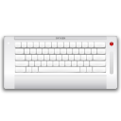

### 2.1.1 System Interfaces

This is a standalone desktop system that does not interface with any other external systems. It requires a desktop computer, computer monitor, computer mouse and standard computer keyboard.

### 2.1.2 Interfaces

Battleship will have a user interface which requires a standard computer monitor, computer keyboard and a standard 3 button mouse. Version 1 of the user interface assumes a normally able user so no accommodation will be made for any disabilities.

The interface will consist of two 10 x 10 grids (See Section 3 for details. ), one for each of two players. For version 1.0 (and earlier), the second player will consist of the computer CPU. Later version may include a second human player.

The game pieces will be placed on the grid in non-overlapping locations contrained wholly within the grid. They must be placed either horizonally or vertically on the grid. Once the game begins, each user “guesses” the location of an opponent’s ships using the 3 button mouse to click on a location of the opponents grid. In the case of the computer player, it will use an internal method to “guess” locations. Much like a human player, if a hit is recorded a simple heuristic will be used by the computer CPU to increase the chances of another hit.

After each “guess” the user interface will display one of 3 states; 1) a miss where no ship is found; 2) a hit on a ship with the ship’s name and 3) a hit on a ship and that ship has been hit in every location that it occupies thus sinking the ship. (i.e. “It’s a hit and you sunk my Battleship). Along with a textual indication, a color indicator in the grid square will also be provided. In case one, the grid square will be colored one color and in cases two and three above, the grid square will be colored a second distinguable color.

The user interface will also note the number of hits and misses per game using text.

When all of the ships of one of the opponents is sunk, the user interface will declare the game over and note the winner using text. A method will be provided to either reest the game and start over or terminate the game.

### 2.1.3 Hardware Interfaces

As noted above, this system only requires a standard computer monitor, computer keyboard and mouse. All interfaces will be handled by the operating system.

### 2.1.4 Software Interfaces

This system must use Windows 7+ operating system as this is a Windows Presentation Foundation (WPF) application and is intended for Windows-based computers

### 2.1.5 Communications Interfaces

There are no external communication interfaces.

### 2.1.6 Memory Constraints

There are no known memory constraints. The memory footprint should be sufficiently small to run on any standard desktop computer on the market today running Windows 7+.

### 2.1.7 Operations

After installation, there are no known specific operational requirements.

### 2.1.8 Site Adaptation Requirements

There are no known Site Adaption Requirements for this application other than those noted above.

## 2.2 Product Functions

The application has 3 main functional phases corresponding to the 3 main phases of the Battleship game. They are described below (Note that the user interface images are only exemplarary. The actual interface may vary from that shown.)

* **Initialization:** Each user is required to start the game and then place their game pieces on their Allied Board. They must be placed either horizontally or vertically with no overlaps and wholly within the board. (See Figures 1 & 2)
* **Game Play:** Each user will take turns guessing the location of the opponents ships on the target grid. This is done via the user interface. Hits (successful guesses) or Misses (unsuccessful guesses) will be noted by the user interface. (See Figure 3)
* **Game Over:** The first player to guess all of the locations of the opponents ships will be declared the winner. At this point the user can reset the play field and go back to the initialization phase or exit the game whereupon the game will exit. (See Figure 4)

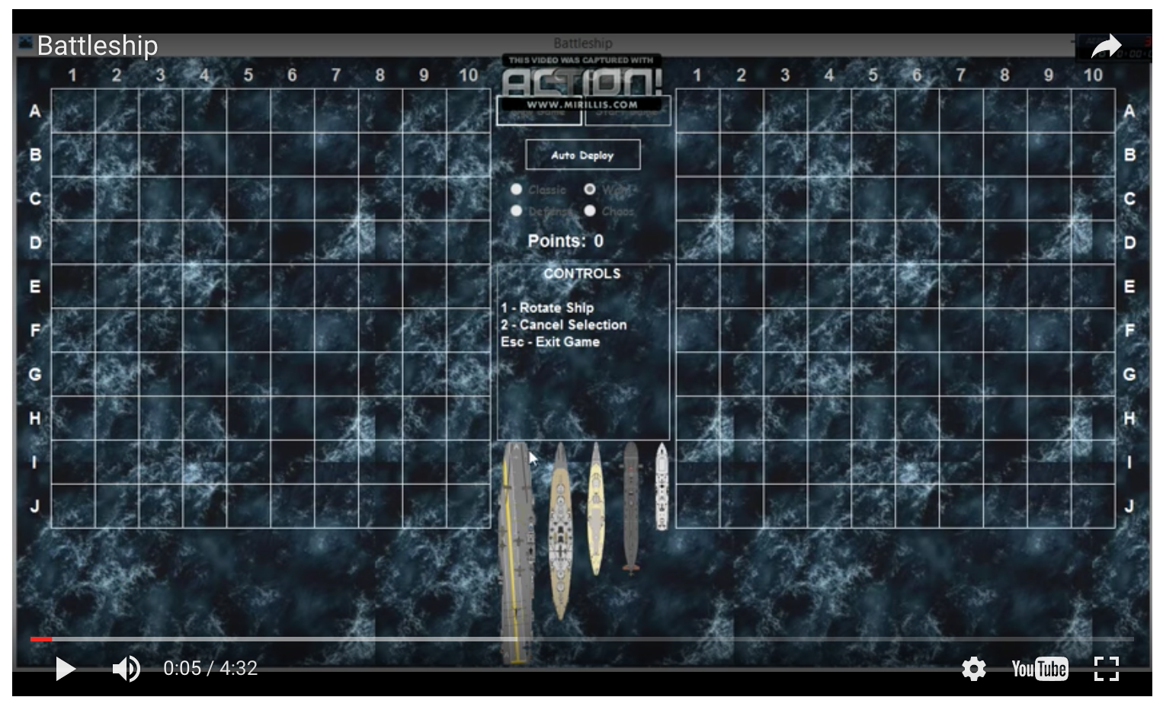

Figure : Initiation Phase

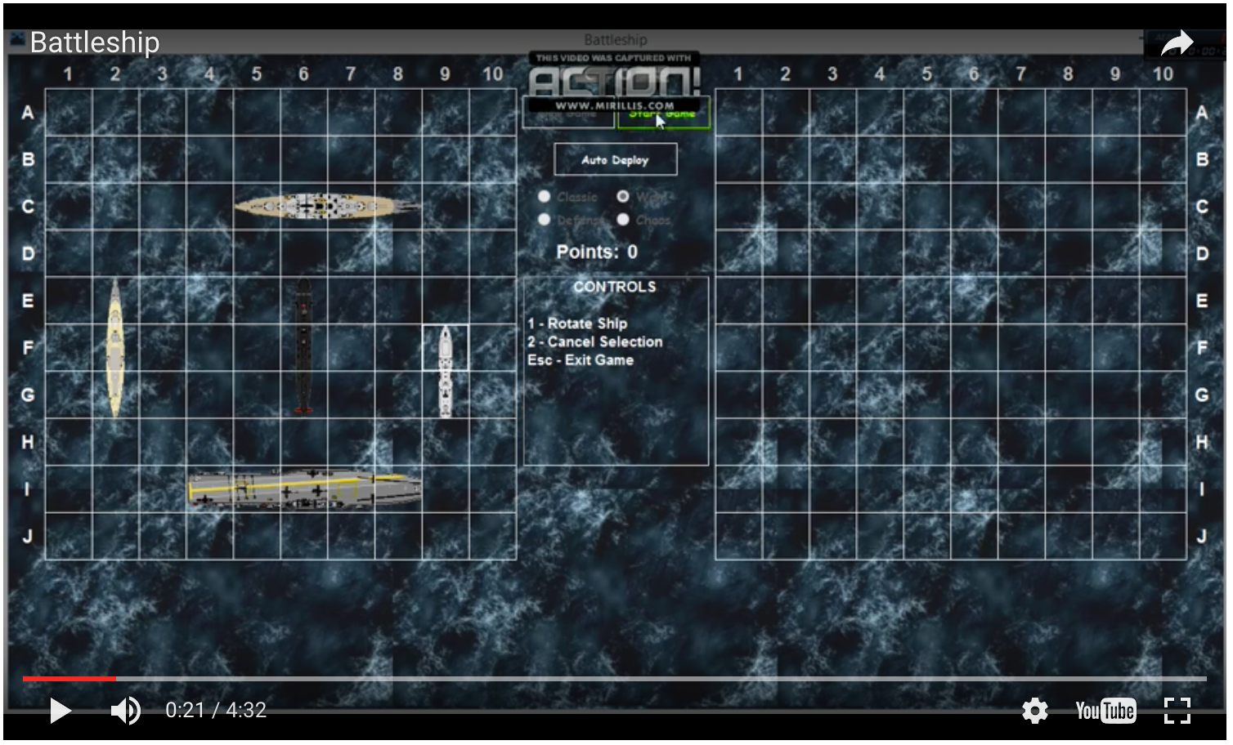

Figure : Initiation Phase with Ships Placed on Allied Grid

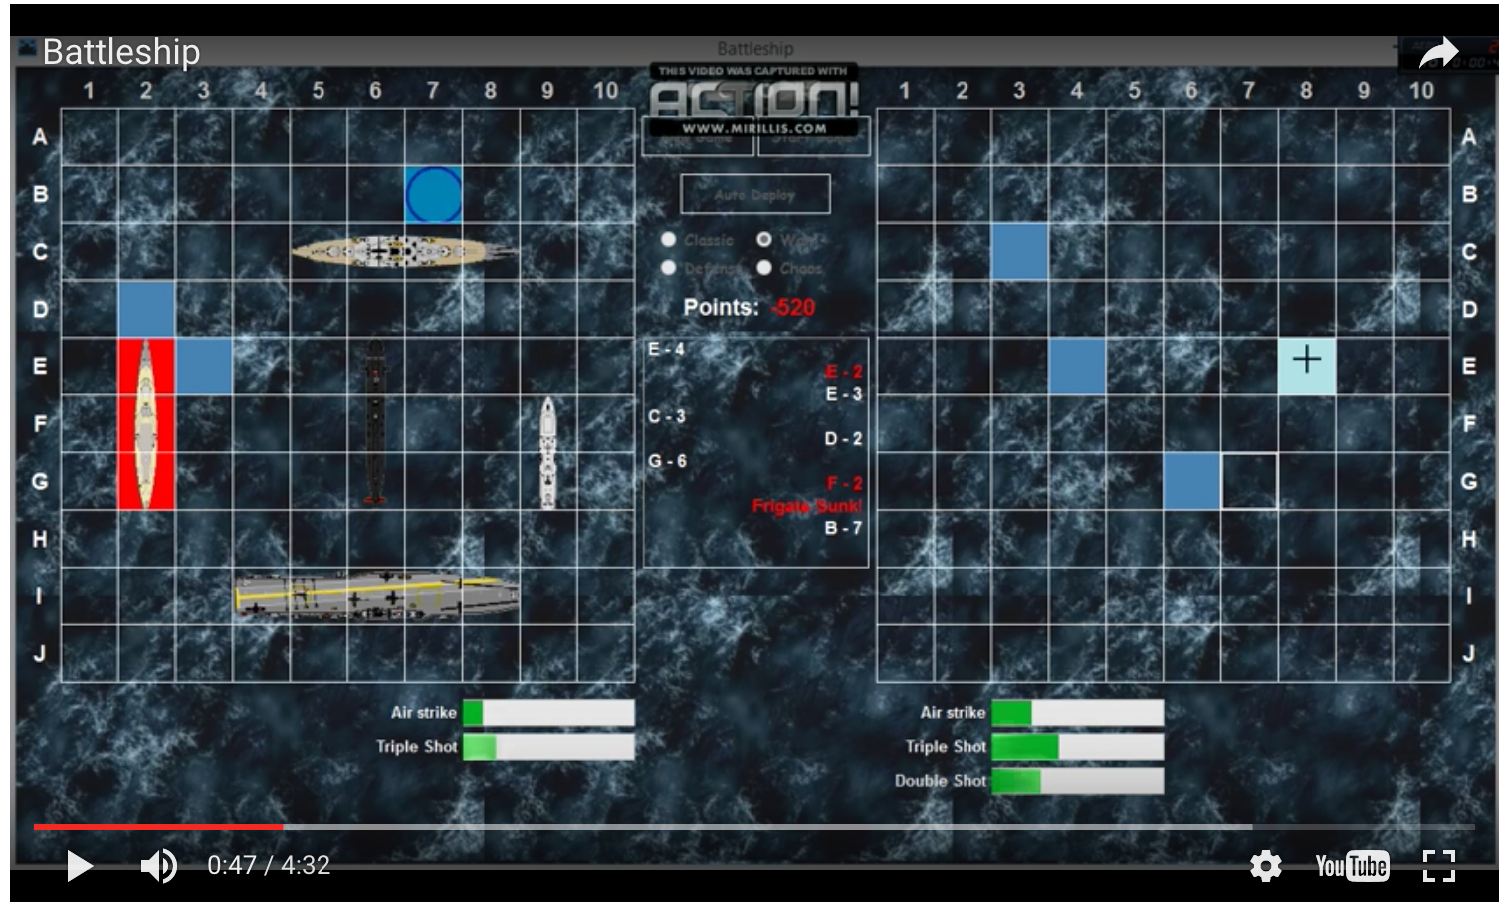

Figure : Game Play (Allied Grid on the Left; Target Grid on the Right)

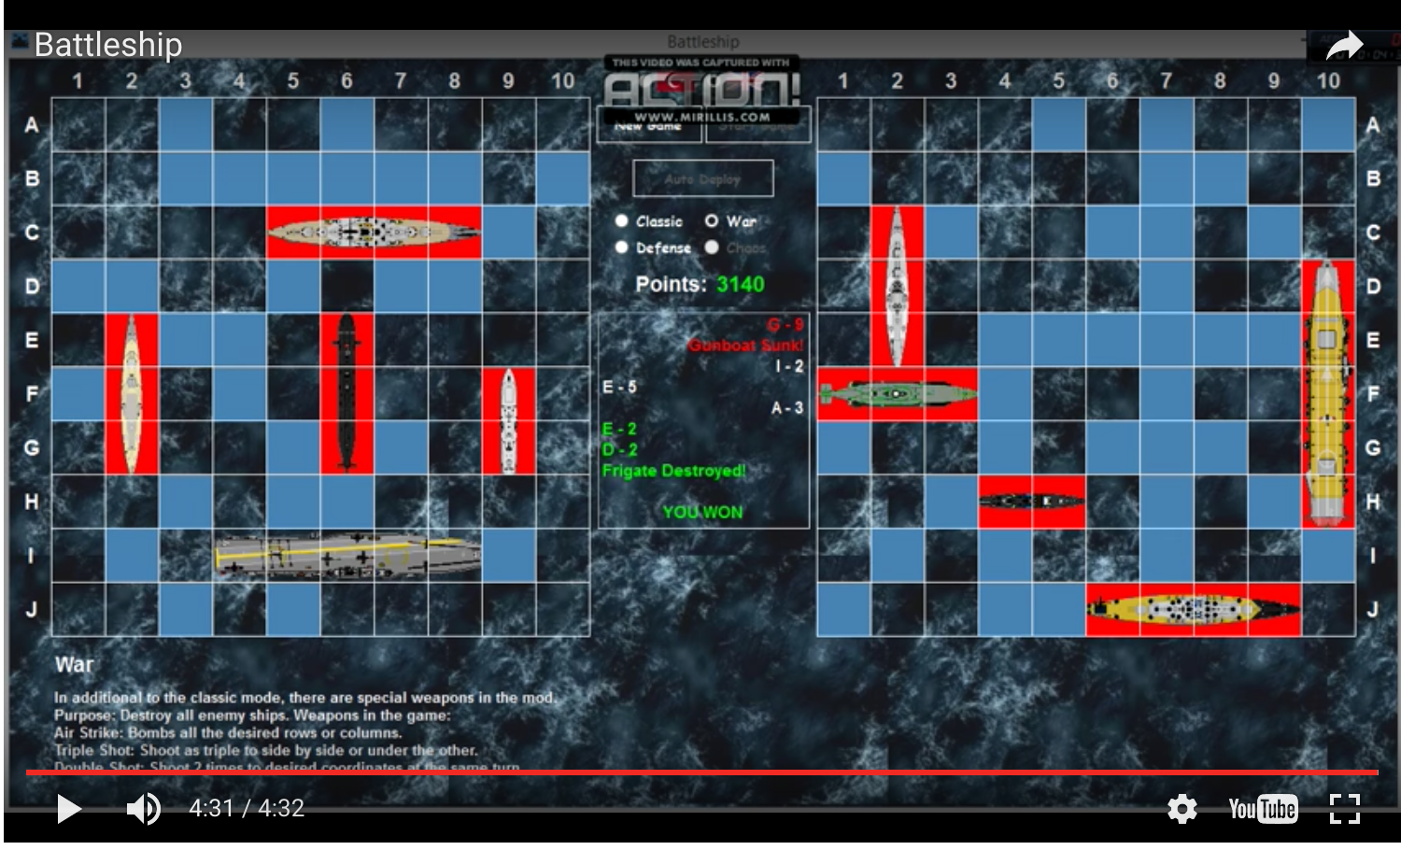

Figure : Game Over (Player has beaten CPU)

## 2.3 User Characteristics

The intended user of this system is a fully-able computer user with moderate-level computer keyboard and mouse manipulation abilities. Elementary education level with less than 1 year experience using a computer keyboard and mouse should suffice. The user must be able to read English directions, manipulate a computer mouse and keyboard and be able distinguish colors on a standard calibrated computer monitor.

## 2.4 Constraints

For version 1. the system is intended for a Windows-based desktop computer with a standard monitor, keyboard and 3-button mouse. It is not intended for as an internet based game with multiple simultaneous users.

## 2.5 Assumptions and Dependencies

For version 1, it is assumed that this system will run as a desktop application running on a computer running the Windows operating system. It is not the intent of this system to run on any other computer hardware devices or desktop computers running any other operating system.

## 2.6 Apportioning of Requirements.

As noted above, version 1 of this system will include one human player and one CPU-based player. Subsequent versions of the system may include a second human player. Requirements will need to be re-examined at that time in order to include communication between desktop systems in order to provide a user experience similar to the board game version of 1967. Further, later versions may run on other operating systems and computer hardware with the first target mostly likely a laptop form factor.

**ANYTHING ELSE?**

# 3. Specific Requirements

## 3.1 External Interfaces

**3.1.1** **Inputs**

**3.1.1.1:** The system shall accept input from a computer mouse using the left mouse button of a 3 button mouse. The input shall record the location where the user wishes to ‘guess’ the location of an opponent’s ship. The application shall only act upon locations within the playing surface of the opponent (for this requirement). All other selection actions will be ignored by this requirement. The user shall only get one ‘guess’ per turn.

**3.1.1.2:** The system shall accept input from a computer mouse using the left mouse button of a 3 button mouse. The input shall indicate that the user wishes to start a new game from the beginning and/or reset the playing surface and begin another game. This input is valid at any point during the game and can be used to exit and/or restart before a game is complete.

**3.1.1.3:** Once requirement 3.1.1.2 is satisfied the user input shall provide a method for the user for placing their own ships wholly within the Allied Grid. Placement shall remain horizontal or vertical (no diagonal ship placement allowed) and wholly within the playing surface. The same or similar method will be provided for the second player. For version 1, the player is the CPU-based player, and for follow-on versions, a second human player.

**3.1.1.4:** For version 1, once the external user has performed requirement 3.1.1.1 and requirement 3.1.2.1 has been satisfied, the application shall accept internal input from the application where upon the second player (for version 1, the CPU), shall ‘guess’ the location of the opponent’s ships. This user will also receives one ‘guess’. Upon completion of this requirement, the opposite player shall receive another guess, unless the game is declared complete and one of the players has ‘guessed’ the location of all of the opponents ships and the game is over.

**3.1.1.5:** The system shall provide a means to completely exit the application at any time.

**3.1.2** **Outputs**

**3.1.2.1:** Upon receiving the input from requirement 3.1.1.1, the application shall indicate via the user interface the following 1) Using textual output, whether the location has found a location covered by an opponents ship or not and the type of ship found 2) The location of the mouse click shall turn a) a single indicative color when the guess did not find a ship or b) a second and different indicative color when the guess has found a location.

**3.1.2.2:** Upon receiving the input from requirement 3.1.1.2, the application shall do the following: If this is the first operation of the game, it shall allow the user to start the placement of its game pieces (See Requirement 3.1.1.3) upon the board or if this is the 2nd or more operation of the game, it shall reset the board which will include removing the previous placement of ships and any indication of guesses (See Requirement 3.1.2.1) allowing the user to place their game pieces upon the playing surface again.

**3.1.2.3:** The user interface shall indicate via text the number of inaccurate guesses as well as the number of accurate guesses.

**3.1.2.4:** The user interface shall indicate via text the location of each player’s guess using a numbering system suitable to distinguish unique locations within the playing surface.

**3.1.2.5**: Once either player has guessed the location of all of the opponents ships, the game shall be declared over and the user interface shall indicates this by using text to indicate the game is over and which player has won.

**3.1.2.6:** The system shall confirm with the user using a textual message when the user indicates that they would like to exit or reset the application before termination of a single game.

## 3.2 Functions

**3.2.1:** **Order of Operations**

**3.2.1.1**: The system shall operate in the following order:

* + The system will be started.
  + One user shall indicate they wish to start a new game.
  + Each user shall be provided a method to place their game pieces wholly within the grid in either a horizontal or vertical position (but not both). Placement outside the grid shall not be allowed.
  + Each user is then given a ‘turn’ which shall consist of indicating where they believe one of the opponents ships is located wholly within the grid. Accurate guesses are indicated differently than inaccurate guesses. Each ‘turn’ shall consist of a single guess. Guesses made outside the grid shall be ignored by the system. Indications should include both textual and color-based methods.
  + The players shall alternate ‘turns’ until all of one player’s ships have been found. One the game is complete, the interface shall allow the user to reset the game or exit.
  + Either player can stop the game at any time by either resetting the game board or exiting the application. A confirmation of the reset operation will be provided in order to prevent mistaken exits and resets.

**3.2.2**: **Abnormal operations**

**3.2.2.1**: Placing ships outside the grid will not be allowed. Any operation which attempts to do so, will be ignored by the application. The ships will remain in their last valid position.

**3.2.2.2**: “Guessing” the location of an opponents ship outside the target grid shall be ignored by the application.

**3.2.2.3**: Each ship shall be placed in a non-overlapping position within the grid in either a horizontal or vertical position. All other placements shall be ignored with ships remaining in their last valid position.

**3.2.2.4**: Attempting more than one ‘guess’ per turn per player will be ignored by the system. 2nd and further guesses will not effect the state of the game.

**3.2.2.5:** If the system shall fail for any reason, the user shall be able to start over from the initiation phase (See above). No information from the previous failed game shall be retained for future use.

## 3.3 Performance Requirements

**3.3.1:** For verison 1, the system shall support a single application running on a desktop computer with a standard computer keyboard and 3 button mouse.

**3.3.2:** For version 1, the system shall support a single human user with a second CPU-based player.

**3.3.3:** For version 1, the system shall run on a Windows®based desktop computer. No internet connection is necessary.

**3.3.4:** For version 1, the system shall indicate via the user interface, the result of the human player’s ‘guess’ in less than 0.5 seconds.

**3.3.5**: For version 1, the system shall indicate via the user interface the choice of the CPU player’s ‘guess’ within 2 seconds but not less than 0.5 seconds. (This is to allow the human user to process and understand where the guess has occurred.)

**3.3.6:** Indication (either valid or invalid) via the user interface of a player’s placement of a single ship shall be completed within 1 second.

**3.3.7:** Indication of reset of the board via the user interface after the completion of a game shall be completed within 1 second.

## 3.4 Logical Database Requirements

This system does not have any database requirements.

## 3.5 Design Constraints

This system is intended to be run on a starndard desktop computer running Windows 7+ operating system. The system requires a standard monitor, keyboard and 3 button mouse. It is not intended for any other hardware devices or desktop computers running any other operating system.

### 3.5.1 Standards Compliance

This system will not comply with any external standards or regulations. There will be standard C# coding style standard applied to the code.

## 3.6 Software System Attributes

### 3.6.1 Reliability

There are not specific reliability requirements.

### 3.6.2 Availability

The system shall be available upon demand from the user on systems upon which it is installed.

The system shall, upon failure, restart the game of Battleship in the initiation mode. All previous game play will be lost.

### 3.6.3 Security

There are no known specific security requirements at this time. No user or game-play information is retained.

### 3.6.4 Maintainability

There are no known maintainability requirements at this time.

### 3.6.5 Portability

For version 1, the system shall run on a single desktop computer system running Windows® 7+ operating system with a standard monitor, keyboard and 3 button mouse. 100% of the code is host/OS dependent. It shall be written in C#(Version #?) using Windows Presentation Foundation®and .Net® technology.

|  |  |  |  |  |  |  |  |  |  |  |  |  |  |  |
| --- | --- | --- | --- | --- | --- | --- | --- | --- | --- | --- | --- | --- | --- | --- |
| **ID** | **Characteristic** | **H/M/L** | **1** | **2** | **3** | **4** | **5** | **6** | **7** | **8** | **9** | **10** | **11** | **12** |
| 1 | Correctness | H |  |  |  |  |  |  |  |  |  |  |  |  |
| 2 | Efficiency | M |  |  |  |  |  |  |  |  |  |  |  |  |
| 3 | Flexibility | M |  |  |  |  |  |  |  |  |  |  |  |  |
| 4 | Integrity/Security | L |  |  |  |  |  |  |  |  |  |  |  |  |
| 5 | Interoperability | L |  |  |  |  |  |  |  |  |  |  |  |  |
| 6 | Maintainability | L |  |  |  |  |  |  |  |  |  |  |  |  |
| 7 | Portability | L |  |  |  |  |  |  |  |  |  |  |  |  |
| 8 | Reliability | M |  |  |  |  |  |  |  |  |  |  |  |  |
| 9 | Reusability | L |  |  |  |  |  |  |  |  |  |  |  |  |
| 10 | Testability | H |  |  |  |  |  |  |  |  |  |  |  |  |
| 11 | Usability | H |  |  |  |  |  |  |  |  |  |  |  |  |
| 12 | Availability | M |  |  |  |  |  |  |  |  |  |  |  |  |

*Definitions of the quality characteristics not defined in the paragraphs above follow.*

*• Correctness - extent to which program satisfies specifications, fulfills user’s mission objectives*

*• Efficiency - amount of computing resources and code required to perform function*

*• Flexibility - effort needed to modify operational program*

*• Interoperability - effort needed to couple one system with another*

*• Reliability - extent to which program performs with required precision*

*• Reusability - extent to which it can be reused in another application*

*• Testability - effort needed to test to ensure performs as intended*

*• Usability - effort required to learn, operate, prepare input, and interpret output*

# Change Management Process

Additions, deletions, and changes to the above requirements shall be completed upon the discussion and vote of the developers responsible for the design and implementation as well as the instructor of the course for which this system is being built. All changes shall be noted within the document.

# Document Approvals

The SRS shall be approved by the developers and the instructor of the course for which this system is being built. All changes will be noted within the document along with the approval date.

# Supporting Information

**6.1** Classic Battleship Rules (see [www.boardgames.com/od/battleship/a/Rules-Battleship.htm](http://www.boardgames.com/od/battleship/a/Rules-Battleship.htm))

[Battleship](http://boardgames.about.com/od/battleship/p/battleship.htm) (or Battleships) is a game for two players where you try to guess the location of five ships your opponent has hidden on a grid. Players take turns calling out a row and column, attempting to name a square containing enemy ships. Originally published as Broadsides by [Milton Bradley](http://boardgames.about.com/cs/companies/a/hasbro_pb_mb.htm) in 1931, the game was eventually reprinted as Battleship.

**Players**: 2 players

**Contents**: Each player gets a board with two grids, five ships, and a bunch of hit and miss markers. (Alternatively, the game can be played with pencil and paper by drawing the grids. Here are the rules for that game, known as [Salvo](http://boardgames.about.com/od/salvo/a/salvo_rules.htm).)

**Goal**: To sink all of your opponent's ships by correctly guessing their location.

### **Setup**

Give each player a board with two grids, one of each type of ship, and a bunch of hit and miss markers. Pen and paper players should note there is one length 2 ship, two length 3 ships, one length 4 ship, and one length 5 ship.

Secretly place your ships on the lower grid.

Each ship must be placed horizontally or vertically (not diagonally) across grid spaces, and can't hang over the grid. Ships can touch each other, but can't both be on the same space.

### **Play**

Players take turns firing a shot to attack enemy ships.

On your turn, call out a letter and a number of a row and column on the grid. Your opponent checks that space on their lower grid and says "miss" if there are no ships there, or "hit" if you guessed a space that contained a ship.

Mark your shots on your upper grid, with white pegs for misses and red pegs for hits, to keep track of your guesses.

When one of your ships is hit, put a red peg into that ship on your lower grid at the location of the hit. Whenever one of your ships has every slot filled with red pegs, you must announce to your opponent that he has sunk your ship.

**Victory**: The first player to sink all opposing ships wins.

### **Salvo Variant (not implemented here)**

To speed up the game, some players play a Salvo variant where you get multiple shots per turn. On your turn, you get to take one shot for each ship you have remaining in your fleet. Once you have announced all of your shots (five, at the beginning of the game), your opponent tells you which ones were hits.